**“ Gujarati Handwriting Recognition ”**

**A PROJECT REPORT**

***Submitted by***

|  |  |
| --- | --- |
| **Sonegra Harsh B.** | **(206270307079)** |
| **Nena Maitri V.** | **(206270307038)** |
| **Naina Kuldip V.** | **(206270307006)** |
| **Desai Riya J.** | **(206270307049)** |

***In partial fulfillment for the award of the degree Of***

**DIPLOMA OF ENGINEERING**

***In***

**COMPUTER ENGINEERING**



**GOVERNMENT POLYTECHNIC, PORBANDAR**

## Gujarat Technological University, Ahmedabad Academic Year: 2022-23

**GOVERNMENT POLYTECHNIC PORBANDAR**



**COMPUTER ENGINEERING DEPARTMENT**

# VISION OF THE DEPARTMENT

To achieve excellence in Computer Engineering by imparting technical and problem-solving skills along with ethical value to meet industrial requirements having social and environmental concerns.

# MISSION OF THE DEPARTMENT

M1: To provides a learning ambiance to enhance discipline knowledge, technical skill and problem-solving skill.

M2: To motivates students for lifelong learning to adapt challenges in rapidly changing technology.

M3: To induces ethical values and spirit of social commitment.

M4: To provide opportunities to promote leadership skill required in Computer Engineering industry’s diverse culture.

# Subject: Project 2

**Subject Code: 3350707**

# Course Outcomes:

|  |  |
| --- | --- |
| C305.1 | Identify problem statement by surveying variety of domains. |
| C305.2 | Identify design methodologies based on requirement analysis. |
| C305.3 | Apply advanced programming techniques. |
| C305.4 | Present technical report by applying different visualization tools and  Evaluation metrics. |

|  |  |  |
| --- | --- | --- |
|  | **GOVERNMENT POLYTECHNIC, PORBANDAR**  COMPUTER ENGINEERING |  |

DECLARATION

We hereby declare that the Reports, submitted along with the Project Report for the project entitled **“Gujarati Handwriting Recognition*”*** submitted in partial fulfillment for the degree of ***Diploma in Computer Engineering*** to Gujarat Technological University**,** Ahmadabad**,** is a Bona-fide record of the project work carried out at ***Government Polytechnic Porbandar*** under the supervision of Respected ***Kartik Detroja*** sir and that no part of any of these reports has been directly copied from any students’ reports or taken from any other source, without providing due reference.

|  |  |
| --- | --- |
| **Student Name** | **Student’s Sign** |
| Sonegra Harsh B (206270307079) |  |
| Nena Maitri V (206270307038) |  |
| Naina Kuldip V (206270307006) |  |
| Desai Riya J (206270307049) |  |

|  |  |  |
| --- | --- | --- |
|  | **GOVERNMENT POLYTECHNIC, PORBANDAR**  COMPUTER ENGINEERING |  |

## CERTIFICATE

**This is to certify that the reports, submitted along with the project entitled “Gujarati Handwriting Recognition*”* has been carried out by *Sonegra Harsh B (206270307079)* under my Guidance in partial fulfillment for the degree of: *Diploma in Computer Engineerin*g of Gujarat Technological University, Ahmadabad during the academic year 2022-23. These students have successfully completed report activity under my guidance.**

|  |  |
| --- | --- |
| **Internal Guide** | **Head of Department** |
| Kartik Detroja Sir | J.M. Pavagadhi |

|  |  |  |
| --- | --- | --- |
|  | **GOVERNMENT POLYTECHNIC, PORBANDAR**  COMPUTER ENGINEERING |  |

## CERTIFICATE

**This is to certify that the reports, submitted along with the project entitled “Gujarati Handwriting Recognition*”* has been carried out by *Nena Maitri V (206270307038)* under my Guidance in partial fulfillment for the degree of: *Diploma in Computer Engineerin*g of Gujarat Technological University, Ahmadabad during the academic year 2022-23. These students have successfully completed report activity under my guidance.**

|  |  |
| --- | --- |
| **Internal Guide** | **Head of Department** |
| Kartik Detroja Sir | J.M. Pavagadhi |

|  |  |  |
| --- | --- | --- |
|  | **GOVERNMENT POLYTECHNIC, PORBANDAR**  COMPUTER ENGINEERING |  |

## CERTIFICATE

**This is to certify that the reports, submitted along with the project entitled “Gujarati Handwriting Recognition*”* has been carried out by *Naina Kuldip V (206270307006)* under my Guidance in partial fulfillment for the degree of: *Diploma in Computer Engineerin*g of Gujarat Technological University, Ahmadabad during the academic year 2022-23. These students have successfully completed report activity under my guidance.**

|  |  |
| --- | --- |
| **Internal Guide** | **Head of Department** |
| Kartik Detroja Sir | J.M. Pavagadhi |

|  |  |  |
| --- | --- | --- |
|  | **GOVERNMENT POLYTECHNIC, PORBANDAR**  COMPUTER ENGINEERING |  |

## CERTIFICATE

**This is to certify that the reports, submitted along with the project entitled “Gujarati Handwriting Recognition*”* has been carried out by *Desai Riya J (206270307049)* under my Guidance in partial fulfillment for the degree of: *Diploma in Computer Engineerin*g of Gujarat Technological University, Ahmadabad during the academic year 2022-23. These students have successfully completed report activity under my guidance.**

|  |  |
| --- | --- |
| **Internal Guide** | **Head of Department** |
| Kartik Detroja Sir | J.M. Pavagadhi |

**ACKNOWLEDGEMENT**

I am grateful to Mrs. J. M. Pavagadhi head of department of computer engineering for providing me all the facility that was required for the successfully completion of our project. Our special thanks of gratitude to our internal guide Kartik Detroja sir for their valuable guidance and support in completing our project.

I would like to thanks to all professors, parents and friends who helped me a lot in finalizing this project within the limited time frame. Last but not the least we are grateful to authors of the reference and other literatures referred to in this project.

## ABSTRACT

The aim of this project was to design and create a machine learning model that gives accurate output to the input from various interfaces. This model allows the input of image that consist of Gujarati handwritten digits and it produces accurate output for that image.

The model interfacing is simple, user friendly and secured after launching it as an API.

The main goal this project is to learn the trending technology and automations. This is to facilitate all people who are in model's use cases.

It has many technical elements and the rules are fairly simple. This simplicity makes it a good choice for learning a new program environment. It covers a range of areas (machine learning, deep learning, mathematics, image processing, etc.) but none too difficult.

**Index**

* Identification of problem definition.
* Learning basics of machine learning.
* Linear Regression for machine learning.
* Gradient Decent Algorithm for machine learning.
* Logistic Regression for machine learning.
* Neural networks.
* Project information and data.
* Conclusion and Future Scope for our project.
* **Identification of the problem:**

As we can see the field of Artificial Intelligence is growing more and more day by day providing accurate result to users with great efficiency and simple user interface, as these models are developed for international languages that are widely used throughout the world like English. We as a computer engineering students of Government Polytechnic Porbandar have chosen project that will identify the images of Gujarati digits. This model will be provided image as an input that will be identified by the model providing accurate output to the given image. This model can be further feed with other characters to solve the problem of translation of images of local languages like Gujarati to text.

* **Learning basics of machine learning.**
  + **Artificial Intelligence**
    - Artificial Intelligence is capability of machines that can take decisions by themselves without any human help and interruptions.
  + **Machine Learning**
    - Machine learning is a way to implement artificial intelligence so that it can learn from the data and take decisions by themselves.
    - The model learns from the dataset that is fed into an algorithm.
    - There are 3 types of Machine learning.
      * Supervised learning: Data labels are provided
      * Unsupervised learning: Data labels are not provided.
      * Reinforcement learning: Type of learning in which a computer learns from result of particular action it performed.
  + **Deep Learning**
    - Deep learning is also a way to implement artificial intelligence so that it can take decisions by themselves.
    - Deep learning uses neural networks and deep neural networks to learn from dataset.

We have learnt following aspects to implement our project.

* Python
* Python libraries.
  + Numpy: for matrix, vectors(arrays) calculations.
  + Matplotlib: for data visualization.
  + Pandas: to load the dataset.
  + Seaborn: to load the dataset and provide some inbuilt datasets.
  + Os: for handing file hierarchy for custom dataset.
  + Glob: file handing.
  + Image | PIL: for loading images and converting it into matrixes.
* Image processing
  + Image gray scaling.
  + Image resizing.
  + Image sharping.
  + Image filtering.
  + Data scaling.
  + Train-test splitting.
* Essential mathematics
  + Linear algebra
    - Scaler, vectors and matrix
  + Statistics
  + Probability
* **Linear Regression for machine learning.**
  + Linear regression is a quiet and the simplest statistical regression method used for predictive analysis in machine learning. Linear regression shows the linear relationship between the independent(predictor) variable i.e. X-axis and the dependent(output) variable i.e. Y-axis, called linear regression*.*If there is a single input variable **X** (independent variable). such linear regression is called ***simple linear regression or univariate linear regression*.**
  + If the **Y** is dependent variable to predict the value of then the formula to predict the **Y** is following:

Y = X * Weight + Bias

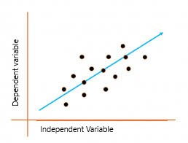

* + The above graph presents the linear relationship between the output(y) variable and predictor(X) variables.  The blue line is referred to as the*best fit* straight line. Based on the given data points, we attempt to plot a line that fits the points the best.
  + **The Weight** and **The Bias** are known as the parameters of model.
  + The Dataset is fed into a model that changes the value of the weight and the bias is changed repeatedly to acquire maximum accuracy**.**
  + The value of parameters is changed by a loss function and gradient descent algorithm.

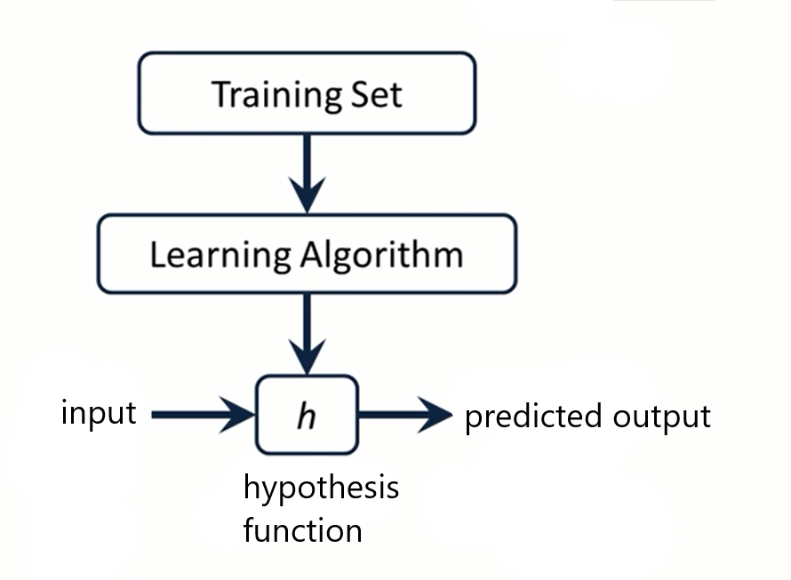

* + The hypothesis function is a trained model that gives output to an unidentified input.
  + Hypothesis function for linear regression: X* weight + bias.
  + This function is trained as per Cost function that is commonly denoted by J.
  + J (Weight, Bias) = m Σ (h (x) – y) ^2.
  + Where h (x) is value the model is now predicting and Y denotes the original value of label during training.
  + The goal is to minimize the value of cost function.
* **Gradient Descent Algorithm**
  + The Gradient Descent Algorithm minimize the cost of h(x).
  + It is an optimizing algorithm that changes the value of parameters while training the model.

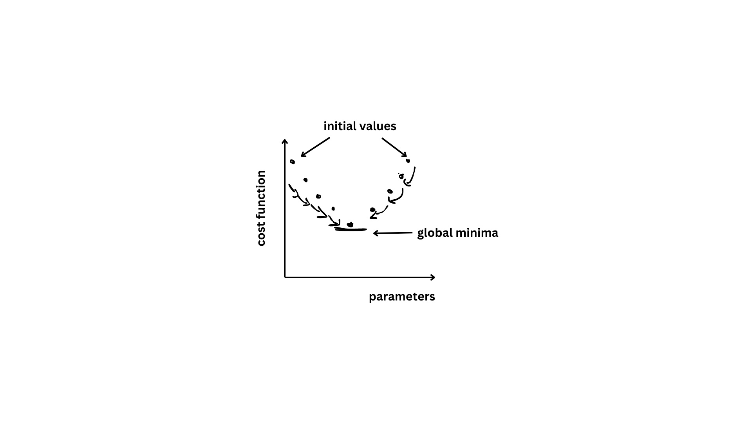

* + To update the parameters, we update the weight and bias as per the model is trained with the data.
  + The value of Weight and Bias will be changed as per following.

Bias = Bias – Rate of change * 1/m * (h(xi) - yi)

Weight = Weight – Rate of change * 1/m * * (h(xi) - yi) * xi

* + For multivariate hypothesis of linear regression
    - h(x) = Weight-1 * X1 + Weight-2 * X2 + Bias
    - Y = w1x1 + w2x2 + …… + Bias
* **Logistic Regression for machine learning.**